Level 13 -> Level 14

In this level we will not get the password to enter into the next level. Instead we need to use the private SSH key to log into next level.

Use the command **cat sshkey.private** to view the key.

This is how the key looks like :-

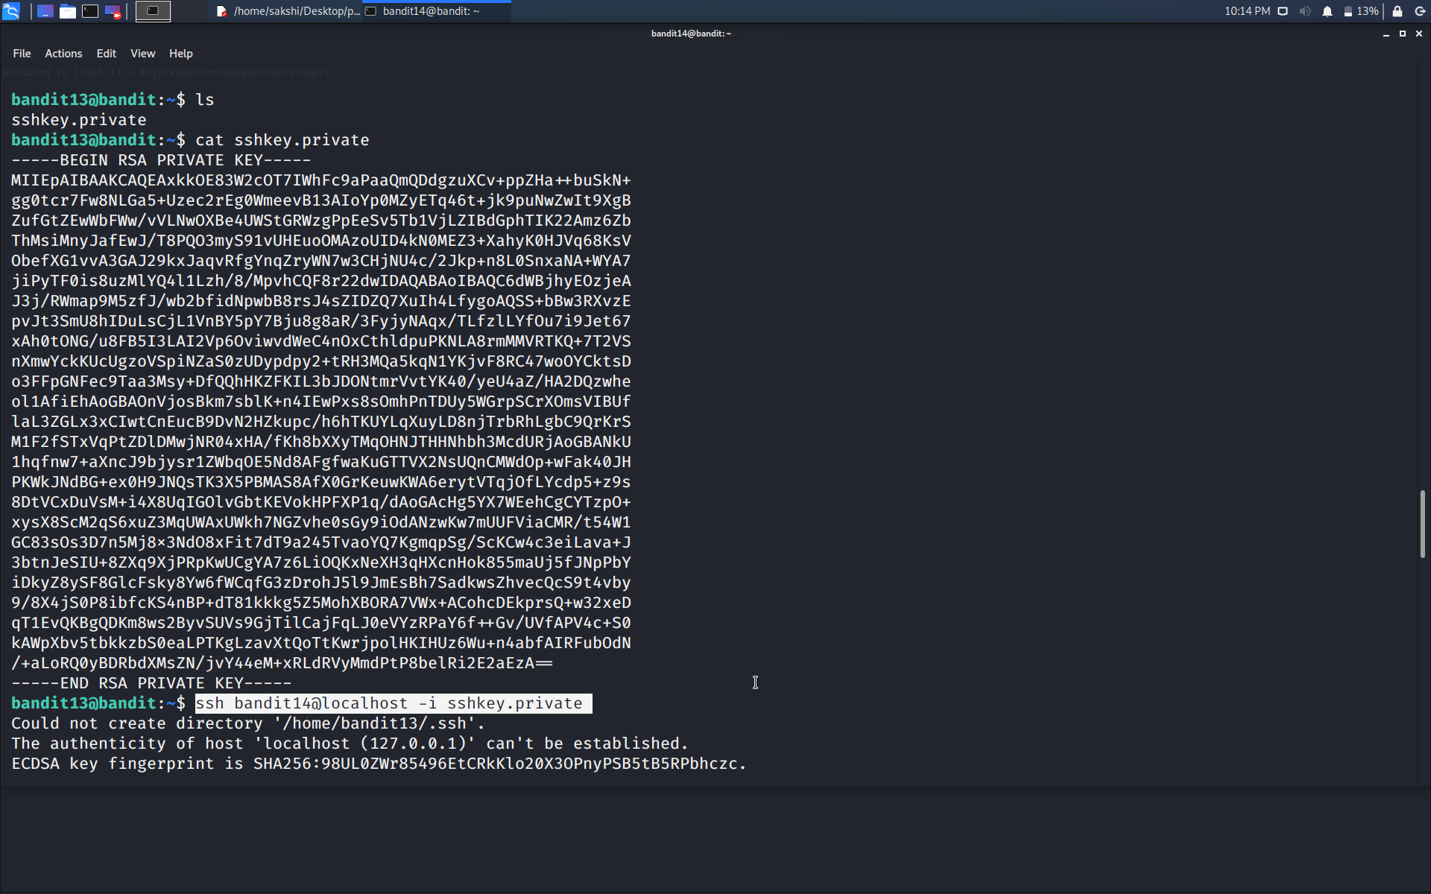

Simply type the command as **ssh bandit14@localhost -i sshkey.private** to login into the next level.

**ssh bandit14@localhost** is used for connecting to bandit14.

**-i sshkey.private** is used to insert the key where option -i is for inserting.

Now, we can enter into the directory /etc/bandit_pass and read the file bandit14 and get the password as we are user bandit14.

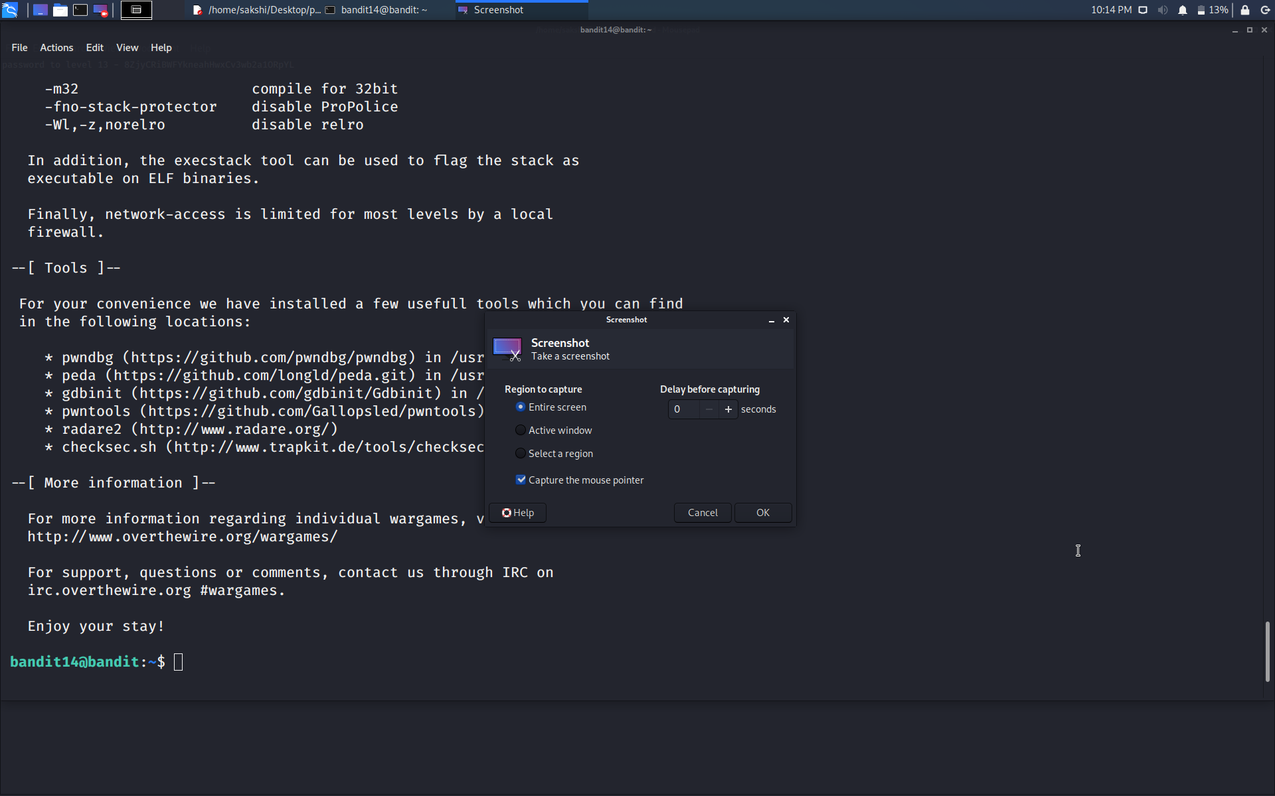

Successfully passed level 14.…